Changes in Master:-
- Master CR - GM / Contractor – Option for Manual Entry for Components
- Master CR – Schema -
  - In Bulk Consumer Master – Add Delete Functionality
  - Bulk Consumer Master – (Add-Update-Get)
  - Vistrit Summary Report - Mapped Status report changes in summary report & abstract report
  - Vistrit
    - Scheme Bulk consumer master :
      - Divide screen into 2 sheets
        - Add Bulk Consumer – Add further fields such as Agreement copy & Total Supply points of bulk consumer. Action Button Edit & Delete
        - Map Bulk Consumer
    - Scheme Village Master:
      - Addition of Validation and logic on “Is a Bulk village”, “Is water supply testing started by firm”, “Is water supply permitted by GM PIU”. Action button check for Edit
      - Check OHT Village Master Mapped column and Census Population
    - OHT Village Master - OHT Master Mapping Report Updations such as local name column addition
    - WTP Meter Mapping – Table column fields increased - like Meter Name, No of Connected OHT, Meter Type, Action Button.
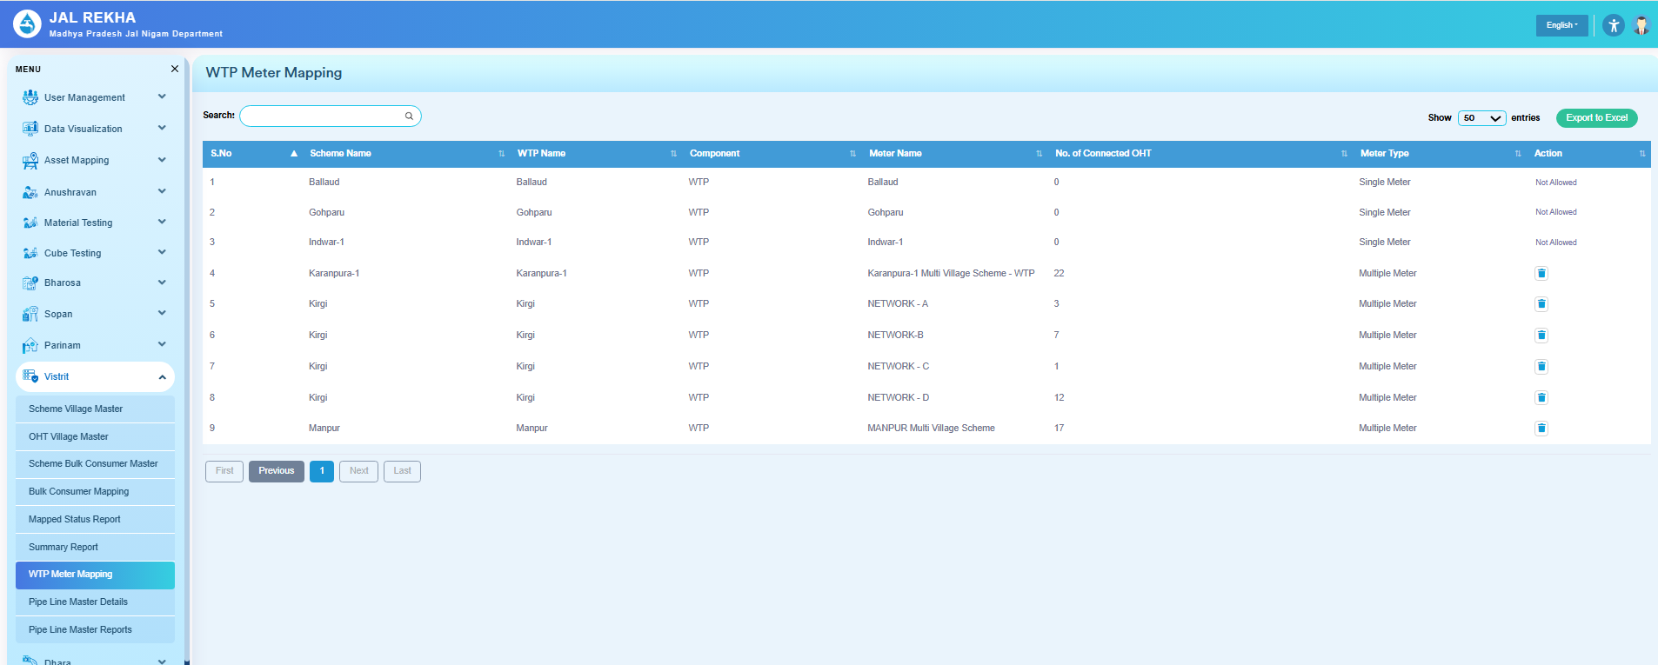

- Addition of Pipeline Master Details & Report Pages.

